**General Circulation: Atmospheric**

**The Wavetable Project**

Have you ever wondered why the clouds in our atmosphere form beautiful and smooth waves? You may be inclined to believe that their formation is random, but it is actually due to a system of factors that we will be simulating today.

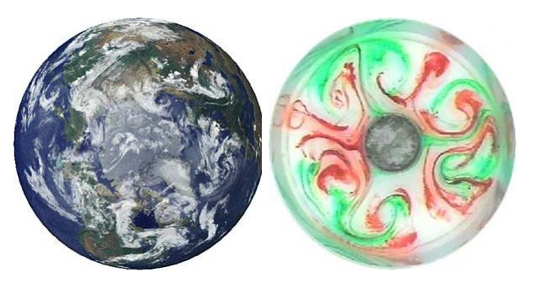

**Figure 1.** Comparing the earth to the lab experiment. [5]

**Before you begin, you will need:**

1. Wavetable
   1. With a RECTANGULAR tank
2. 3 jars
   1. Approximately 2-3in diameter x 5+in
3. Food grade dye
4. Ice
5. Hot water
6. Thermal camera (Optional)
7. Camera or iPhone
8. A computer that can connect to the camera. (Secondary Screen)

**Safety:**

1. Keep all exposed wires away from the water tank
2. Keep all long hair tied back and away from any spinning parts of the setup
3. Keep all laptops and computers away from the tank of water. Water has a tendency to leave the tank when spun too quickly, and removing all valuable electronics from the ‘spray zone’ is a good precaution.

## Experiment 1

1. **Fill ONE of the jars with hot water, and place it in the center of the wavetable tank. Then, fill the tank with normal tap water and place the tank on the wavetable.** *NOTE: Before you start the wavetable, mount your phone or camera on the side of the table, looking side-on, into the fluid. The camera should not be too close to the fluid, or else you will lose part of the shot. You should be able to see most of the sides of the tank. See Figure 2 for an example.* **Set the rotation rate to** set 2 **and wait for solid-body rotation to occur.**

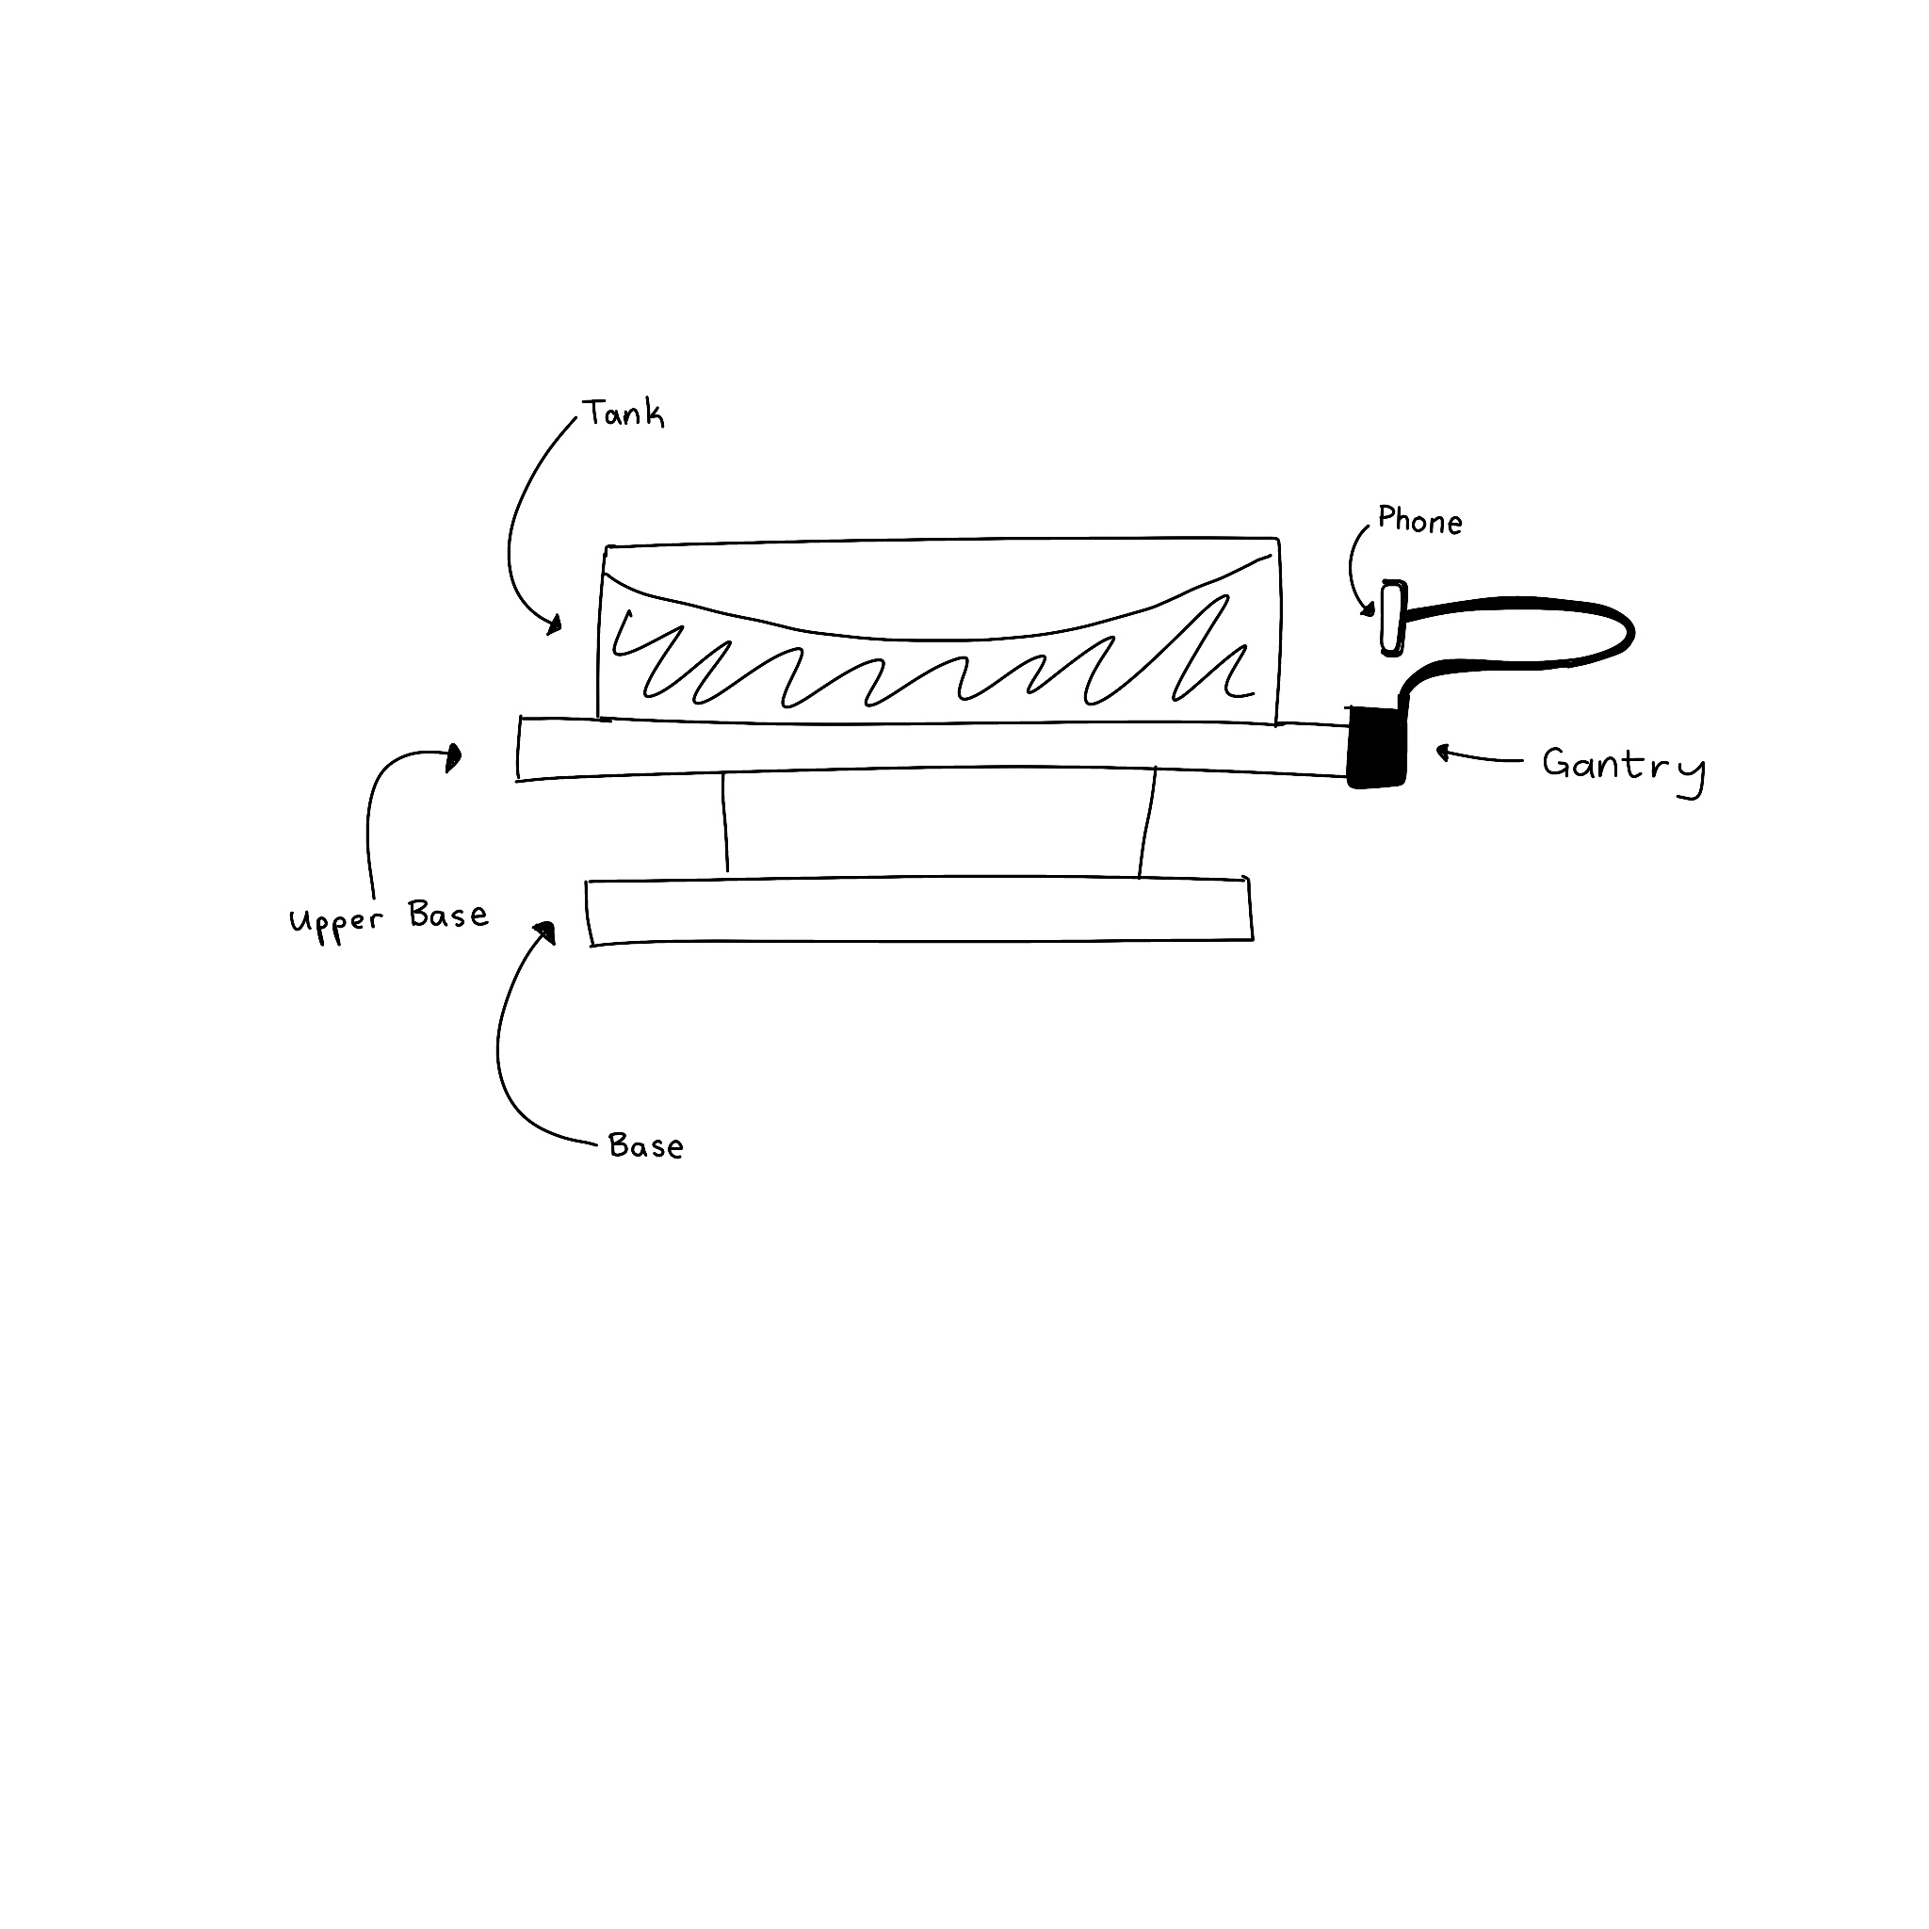

**Figure 2.** Wavetable and phone set-up for experiment.

*Please read:*

Atmospheric circulation, or just general circulation, is the study of how many ingredients come together to dictate the circulation patterns in the atmosphere. In this lab, we will be exploring two types of circulation, one regarding Hadley cells and the other regarding atmospheric eddies.

Named after 17th century English lawyer George Hadley, Hadley cells are pockets of atmospheric circulation. Although he was a practicing lawyer, his true interests lay with the mechanics behind the behavior of the trade winds. In 1735 was elected a Fellow of the Royal Society during the same year he published his paper *Philosophical Transactions,* arguing for his explanation of circulation. Over time his theory was referred to as the “Hadleys Principle” and he was eventually the namesake for the Hadley cells. In these cells warm equatorial air rises, moves poleward, and then descends back down the surface near a latitude of 30°. Similar circulatory cells, called the Polar and Ferrel cells exist to move air through other latitudes.

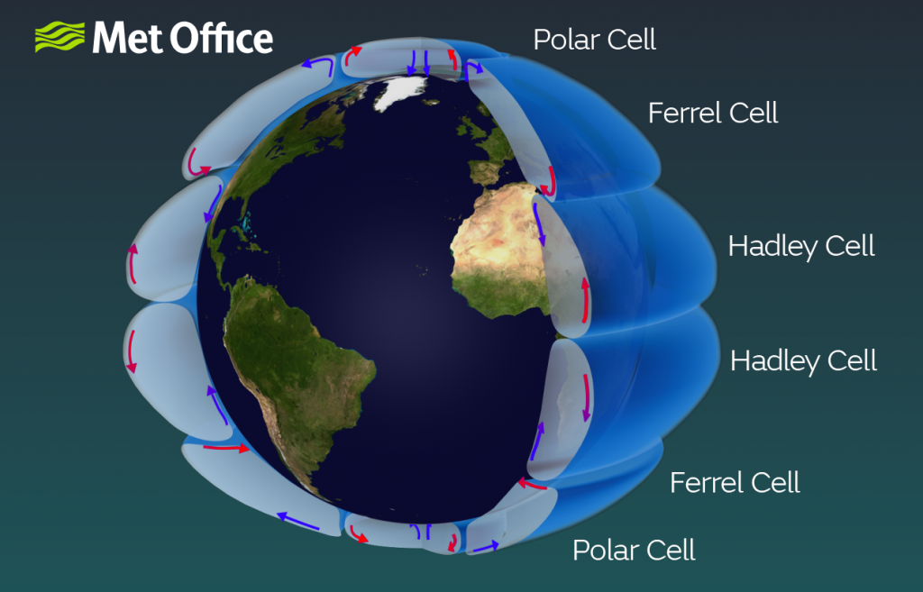

**Figure 3.** From the UK-based weather service, the MET Office is a diagram illustrating the size and positioning of the earth's atmospheric cells. [1]

1. **Once the water has reached solid body rotation (should take ~10 minutes), drop some food dye right next to the jar inside the tank. From the camera mounted on the side of the wavetable, observe how the dye moves.**

Does it fall? How does it change over time? One minute? Five minutes?

|  |
| --- |

1. **Now using the thermal camera, record what else you can see in the tank. (Optional—If you do not have a thermal camera attachment, skip this step.)**

How is the entire system being affected by the jar of hot water? If you can observe any systemic patterns or movements, try to hypothesize why they might be happening.

|  |
| --- |

*Please read:*

The second type of atmospheric circulation we will be examining is extratropical, or eddying, circulation. Named as such because of their presence at the poles as opposed to the low latitudes, extratropical circulations are what dictates the shape the Jet stream forms, and the extreme temperature waves some of us experience.

They form near the poles, and the shapes which they form are called atmospheric waves. We will go much further into depth about these types of waves, but for now, all we need to know is their name. Their specific shapes, which change constantly, are effects of high and low-pressure pockets of air pushing the jet stream. Below is a figure to help visualize the type of flow being discussed.

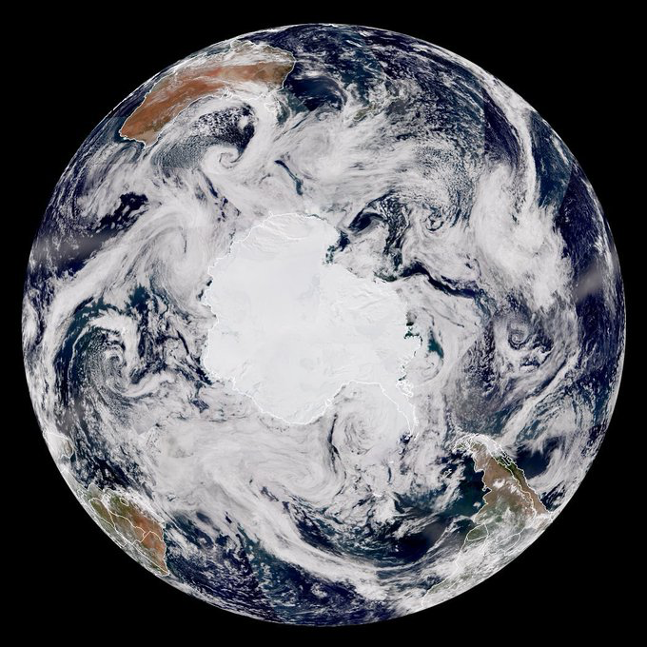

**Figure 4.** Top-down view of the north pole, with clouds illustrating the wave-like shape derived from the jet stream and the trade winds.[2]

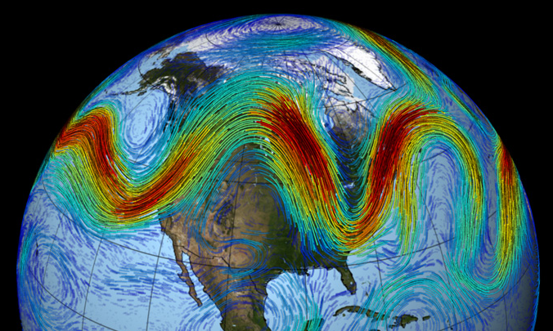

**Figure 5.** A moment in time where the Jet stream behaves like a wave. [6]

These flows transport air around the high latitudes of the globe, and their behavior largely governs the weather countries in Scandinavia, northern Europe, and Russia receive. The waves are shaped by two main factors, each changing constantly. First is the *Polar Vortex,* and the second is the *Weak Warm Trade Winds*. In a stable scenario, the polar vortex is a circulating mass of cold polar air, trapped in the higher latitudes, never venturing down towards the tropics. But, as is the case with our planet, the fluctuating warm winds from the tropics tend to impair the polar vortexes’ ability to stay stable. When the warm trade winds are weak, it leaves space for the polar vortex to push outwards, creating a wavy jet stream; but when the trade winds are strong enough, they tend to keep the polar vortex in a relatively stable condition.

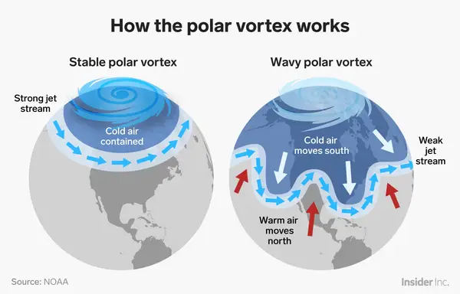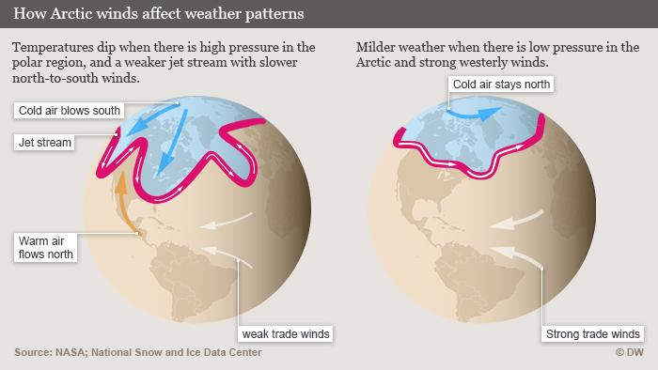

**Figure 6.** An example depicting the fluctuations of the polar vortex. **Figure 7**. Infographic explaining the relationship between trade westward trade winds, the polar vortex, and weather patterns. [3][4]

These pockets of warm and cold air tend to stagnate for a while before breaking equilibrium and moving on. But before they do, they can last for weeks at a time, bringing drought or flooding to many regions.

In this lab, we have been primarily utilizing heat differences to visualize the different types of circulation. In the eddying circulation part of the lab, you can use (if you choose this combination of ice and heat sources in the next step) a can of ice water, placed in the center of the rotating tank to simulate the polar vortex, and then use dye to visualize the waves—see figure 1.

1. **Now that we have a preliminary knowledge of how heat can affect flow in the atmosphere, it’s your turn to experiment with different setups. Using the other one or two jars you have, put cold or hot water in them, and arrange them in the tank. They can both be cold, both be hot, one cold one hot, or if you have three jars: any combination in between.**

*Record your experiments below*

| **Contents of the jars** | **Sketch a picture of the tank, heat/cold sources, and the resulting waves** |
| --- | --- |
| Ex. 1 cold 2 hot |  |
| ______ cold ______ hot |  |
| ______ cold ______ hot |  |

**Glossary**

* Stratocumulus Cloud
  + A large low-level group of clouds is usually observed to be in the shape of long blunt edges.
* Centrifugal Force
  + The force on a spinning object parallel to its instantaneous direction of motion

**Examples**

**References**

1. <https://www.21stcentech.com/tropics-bigger-50-kilometers-decade-world-warms/>
2. <https://www.nesdis.noaa.gov/content/earth-day-50-our-planet-polar-orbit>
3. <https://www.businessinsider.com/polar-vortex-dangers-why-it-happens-2019-1?scrlybrkr=6e2576e5>
4. <https://www.dw.com/en/understanding-the-polar-vortex/a-17347788>
5. <http://weathertank.mit.edu/links/projects/general-circulation-an-introduction>
6. <https://physicsworld.com/a/summer-weather-extremes-linked-to-stalled-rossby-waves-in-the-jet-stream/>